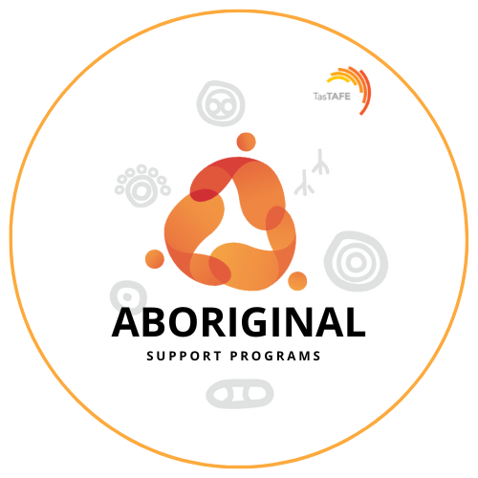

Aboriginal Support Programs (ASP) is the Aboriginal* student support unit at TasTAFE. ASP staff are here to support and assist Aboriginal students to achieve the best possible outcomes in their chosen studies.
Each student that ticks the Aboriginal or Torres Strait Islander identifier on the TasTAFE Enrolment form receives a letter outlining the support and assistance available to them during their studies.
Support and assistance ASP provides can include:
- Course fee, material and uniform/PPE Financial Support^
- Tutorial/study assistance for eligible courses^
- Travel, accommodation and childcare assistance associated with study ^
- TasTAFE course information and advice
- Completing forms associated with studying, e.g. Eligibility, Abstudy, TasTAFE, etc.
- Referrals to other support services, internal and external
Tasmanian Training Awards
Do you have an Aboriginal Student who has demonstrated a real aptitude for their training or displayed high level commitment or worked hard to achieve their qualification or just been overall outstanding? If so, have a chat with your local ASP Staff member.
We are always looking for potential nominees for the Tasmanian Training Awards, specifically the Aboriginal and Torres Strait Islander Student of the Year Award. TasTAFE have a long history of nominating for this award with very successful results.
We fully support students through the whole application, interview and award night process.
Teacher recommendations/suggestions of students would be greatly welcome and appreciated.

NAIDOC Week
Every year TasTAFE recognises NAIDOC week with the ASP team hosting events and celebrations on the major campuses. Each year the National NAIDOC Committee chooses a theme with the aim to create awareness and educate the boarder Australian community on history, culture and achievements by the Aboriginal Community.
All celebrations are based on the annual theme and everyone is invited to participate. Keep an eye out for information on NAIDOC Week events at your local campus during the first week of July each year.
Contact us
If you would like more information or are aware of any Aboriginal students who may be interested in, or need to access our support, please do not hesitate to contact us, here’s how;
South:
Jan Langridge, on 616 55803 or email Jan at Jan.Langridge@tastafe.tas.edu.au
Office Hours: Monday to Friday – 9.00am to 5.00pm
North:
Amy Whiting, on 677 72515 or email Amy at Amy.Whiting@tastafe.tas.edu.au
Office Hours: Tuesday 9.00am to 5.00pm, Wed & Thurs – 9.00am to 2.30pm
North West:
TBA
Devonport Campus ph: 647 84246
Burnie Campus: ph 647 77504
Email aboriginalprograms@tastafe.tas.edu.au

Team shared mailbox aboriginalprograms@tastafe.tas.edu.au
Phone 1300 655 307 and ask to speak to an ASP staff member.
Like us on Facebook to keep up to date on courses, scholarships, events, activities, resources, positions vacant, etc -click here
^ Tasmanian Government Eligibility Guidelines apply
* All reference to Aboriginal includes Torres Strait Islander

